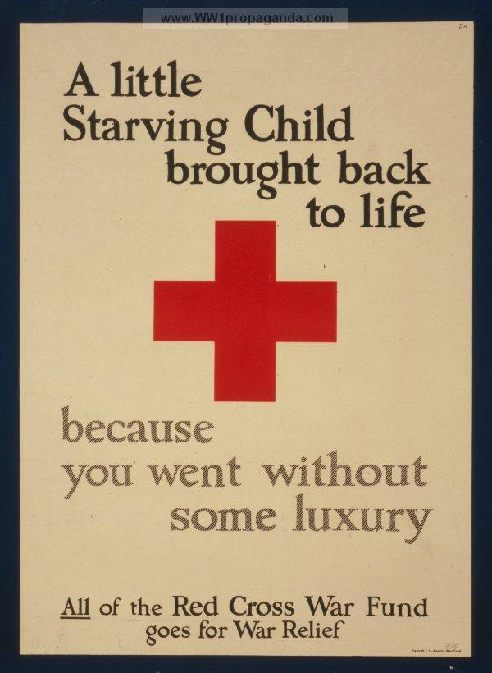

http://www.ww1propaganda.com/ww1-poster/little-starving-child-brought-back-life-because-you-went-without-some-luxury-all-red-cros

In this propaganda I feel that many people may think this is bias because what this poster is saying is that the rich don't deserve what they have because it can hurt kids because they don’t have what they need so they are dying. Also what this shows is that since its bias why not stop this and the rich help the poor and who are in need. Many children did die during World War 1 but the rich are able to prevent even though they worked hard for what they have. This was the Red Cross so they made this funding to help many people.

